SQL to PySpark Phase 1 – Simple Foundation Pack

CREATE TABLE customers (
customer_id INT,
customer_name VARCHAR(50),
city VARCHAR(50),
age INT
);
INSERT INTO customers VALUES
(1, 'Ravi', 'Hyderabad', 25),
(2, 'Sita', 'Chennai', 32),
(3, 'Arun', 'Hyderabad', 28);

1) Show all customers
select * from customers;
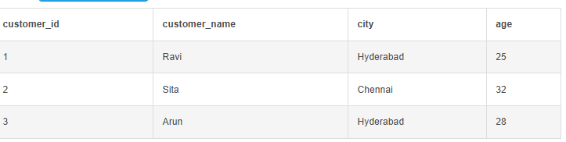

2) Show customers from Chennai
select * from customers where city ="chennai";
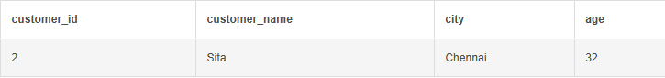

3) Show customers with age > 25
select * from customers where age>25;
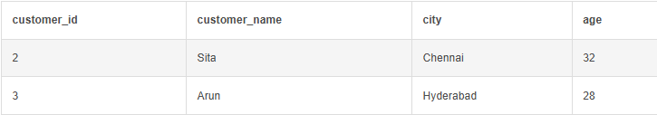

4) Show only customer_name and city
select customer_name,city from customers;
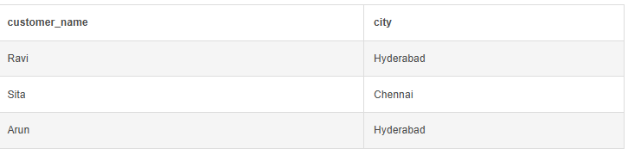

5) Count customers city-wise
select city, count(customer_id) as "number of customers" from customers
group by city ;
